The Gauss seidel method is used to speed up the iteration process. Here we can see that from the Gauss seidel method, after 20 iterations it returns a very large value compared to the answer given by the Jacobi method after 20 iterations.

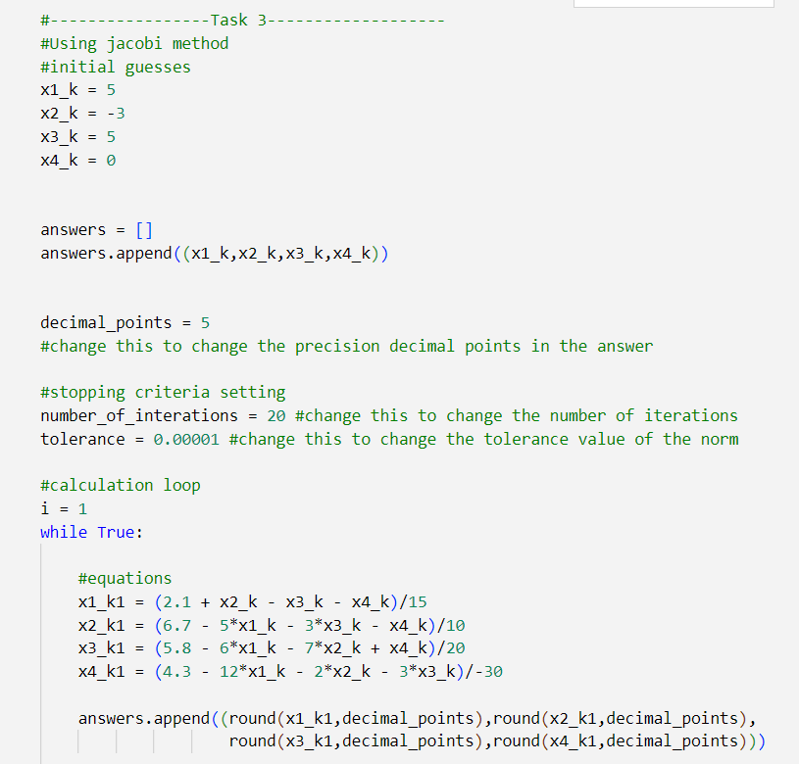

From the results of both methods we can see that using gauss seidel method returns the answer from comparatively less amount of iterations.

Hence the solution for the system of linear equation using Jacobi method and Gauss seidel method is,'

x1 = 0.178

x2 = 0.57377

x3 = 0.03426

x4 = -0.03046

Tenth power of initial guesses vs Number of iterations

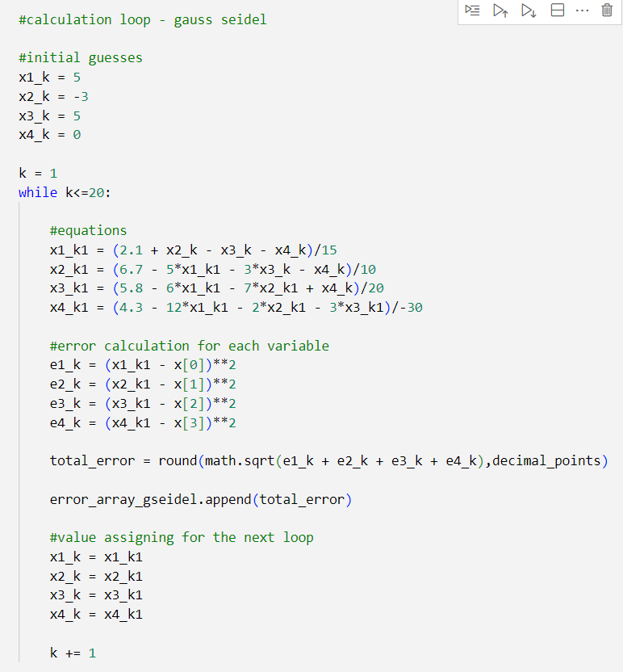

Iteration Number vs Error